**MILLENNIUM NEWS**

Waikanae Millennium Rebus Club

**Website: www.waikanaemillenniumrebus.nz**

**Vol. 26 Issue 4 APRIL 2025**

**2024**

**YOUR CLUB COMMITTEE 2024-2025**

President David Funnell 021 260 6811 Speakers Don Mathieson 04 904 1260

Vice President Ann Harkness 027 430 3534 Almoner/Carer Judith Binning 021 168 1574

Secretary Ann Harkness 027 430 3534 Hall Set-up  Liz Thevenard 021 0528 205 Treasurer Robert Johnson 027 631 3339 Newsletter David Goggin 022 6202 236

Past President Liz Thevenard 021 0528 205 Newsletter Delivery Margaret George 04 293 1313

Cameo Speakers Judith Binning 021 168 1574 Health & Safety Bruce Scott 027 442 6118

Membership/Webmaster  Cathy Mitchell 04 479 2993 Archivist John Roberts 04 904 0959

Dineouts Charlie Metcalfe 021 165 5362 Speakers Shirley Clarke 027 742 3131

Outings Maggie Copland 027 479 1487

**Life Members:** Rob Graham, Beryl Graham, Chris Lehen, David Goggin, Hugh Scott, Alison Viskovic.

**PRESIDENT’S PAGE**

Waikanae’s long dry period has now well and truly finished, with the steady downpour over the last few days the garden has indeed benefitted. Let us hope we still have many more sunny days still to come.

At the April meeting we enjoyed learning about our Treasurer, Roberts early life, before being entertained by Jeremy Winter, who took us back to the WW1 era, with stories of those sad times and music that made it bearable. It was an end of an era, when David Goggin announced that after eighteen productions the Golden Oldies Movie Group would be disbanding. They have been such a large part of our club for the past ten years. Thanks go to all the members who participated in these movies, especially to David for the many hours of dedication.

Fifteen members recently dined at the Winemakers Daughter and enjoyed this venue before it finally closes as a public restaurant. This was also Cathy’s final event as Dine-out coordinator, so thanks Cathy for doing, what can be a frustrating job.

The weather was kind for the fourteen members that attended the Kimbolton Sculpture Festival, with just a few brief showers, but it did not spoil a very enjoyable day. We travelled in two self-drive mini vans, which was a much cheaper option to a hired bus. There were so many interesting things to see and experience at the festival. We also had a bonus of an ice cream and fresh strawberries at Lewis Farm on our way home. Thanks for organising, Liz.

There are two Club events coming up. The May dine-out to Club Vista at Paraparaumu Beach and the June outing to the National Library and Old St Pauls, so book your place soon.

Now the Club is no longer incorporated, we must legally adopt a new Constitution, which will be similar to the old one, so a special AGM will be held in a few months’ time, to finalise this matter.

**David**

**TIDY-UPPERS – MAY – MAGGIE COPLAND and JANET DRYSDALE**

**This is NOT an onerous task – vacuuming the floor only. No moving chairs or tables – just vacuuming.**

***PLEASE NOTE - If you are unable to do your turn, please find a replacement to stand in for you and***

***advise David Goggin, Phone 022 6202 236 or the President of your replacement.***

FOUND IN BOOK - IS THIS YOURS?

Does anyone in the Club have friends in Whanganui called Janine & Patrick Spence?  If so, the Spence Christmas Letter for 2023 was found inside a Kate Atkinson book of Short Stories entitled "Normal Rules Don't Apply" on the Book Table at the last meeting. Nobody at that meeting claimed the letter, but if you do know friends of that name, please contact Anne Wall,04-293-5000, who will return their letter to you.  It was  assumed that  the folded up letter (3 pages) had been used as a book-mark.

|  |
| --- |
| **Next Meeting**  **TUESDAY 6th MAY at 2pm**  **Waikanae Community Centre, Utauta Street**  ***Guest Speaker: Lawrence Kirby***  ***Deputy Mayor, KCDC***  ***Cameo Speaker:*** |

**APOLOGIES**

**Please Telephone Cathy Mitchell 04 479 2993 or 027 206 7831**

**PLEASE REMEMBER**

***# To wear your Name Tag # Tick your name on the Attendance Sheet***

***# Collect your Lucky Number # Support the Raffle***

**APRIL MEETING**

**Attendance:** Present: 67 Apologies:17 Silent: 24

**Raffle Winner:** Cheryl Allerby **Lucky Number:** Patr Fletcher

OUR ALMONER/CARER

Our Club’s Almoner/Carer is **Judith Binning.** P**hone 021 168 1574**, **email** judywilliams6@hotmail.com

If you know of a club member who is not well, has had a bereavement, or may need transport to a meeting, please let Judith know.  Also contact her if you know someone has a milestone birthday or anniversary coming up. Then Judith can make contact or send an appropriate card from the club.

**MEMBERSHIP MATTERS**

**RESIGNATION**

**Shirley Morrison** has resigned after many years as a member. We wish her well for the future.

*If your address, email, etc has changed please inform Cathy Mitchell**04**479 2993 or 027 206 7831*

THE INDOMNITABLE WALKING GROUP

Mad Dogs and Englishmen go out in the Midday Sun.

These mad Waikanarians go out in the Rain and Wind for Fun.

Bravo Maggie Copland, Margaret George, John Roberts, Jennifer Komar and Diana Roberts.

Rosemary Wells took the Photo.

INTEREST GROUPS

**WALKING GROUP**

Conveners: Rosemary Wells Ph: 293 7421 and Jennifer Komar Ph 027 726 4671

Meets 9.45am every Wednesday for coffee (wet or fine) followed at 10.30 for a one-hour or 30-minute walk.

If you require transport, contact either Rosemary or Jennifer before Wednesday.

16 April Long Beach for North Waikanae Beach from Oliver Grove (402)

23 April Harrisons for Derham Road (303)

30 April Vintage Village for Express path Raumati to Poplar Avenue (616)

07 May Long Beach for Waikanae River Southern Bank (410)

14 May Olive Grove for Waikanae Downs (434)

21 May Ambience for Airport Walkway from Tahi Road (516)

28 May Riverstone for Waerenga Road (104)

 BOOK GROUP

Convenor: Anne Wall. Phone 293 5000. Meets 2nd Monday of the month.

The Group is meeting on **Monday** **12th May at 2pm**

at the home of **Sue Hodgson**

*We would very much like to have another member for our Group who enjoys reading, both fiction and non-fiction, and is available on the second Monday of each month in the afternoon.*

*Please contact* [*anne.belvedere@gmail.com*](mailto:anne.belvedere@gmail.com) *if you would like to join us.  We actually have room for TWO new members, but even one would help.'*

CYCLING GROUP

Convenor: David Funnell. Phone 021 260 6811

**Meets every Monday morning at 9am**.

If you are interested in joining this group ring David.

 COMPUTER SUPPORT GROUP

Convenor: David Goggin, Telephone 022 620 2236

Meets 2nd Thursday of the month.

The next meeting is on **Thursday 8th May 2025** at **10am**

at the home of **TBA**

 WRITING FOR FUN GROUP

Convenor Alison Viskovic. Phone 021 159 4945. Meets on 2nd Tuesday of the month.

Next meeting **Tuesday 13th May at 2pm** will be at

the home of **TBA**

*We have a vacancy for one person if a newer member would like to join****.***

 MUSIC GROUP

Convenor Diane Aviss. Phone 293 7434. Meets 3rd Wednesday of the month.

Next Meeting **Wednesday 16th April at 2pm**

at the home of **Alison Viskovic**

 DISCUSSION GROUP

Convenor Rosemary Wells. Phone 293 7421. Meets 4th Friday each month

The group will meet on **Friday 25th April at 10am**

at the home of **Sue Hodgson**

GARDEN GROUP

Convenor Kirsty Provan, Phone 021 0264 7486, Meets 4th Thursday morning each month.

***If you want to know more contact Kirsty.***

**BOOK AND DVD LIBRARY**

At each meeting tables laden with books, jigsaws and DVD’s are available for members to borrow. There is no checkout list to sign, it’s just help yourself and no time limit for keeping the books and puzzles.

It is requested that you make your selections before the meeting starts or during afternoon tea - not after the meeting as they are then very busy packing up.

***Anyone wanting a book between meetings ring: John Harkness 021 481 85 or Ann Harkness 027 430 3534***

**OUTINGS AND DINEOUTS**

***Please wear your Name Tag to all Activities***

***Please remember to put your name on the Intention Sheet before you pay for the Activity.***

***You can pay at the club meeting before***

***an Activity or Online.***

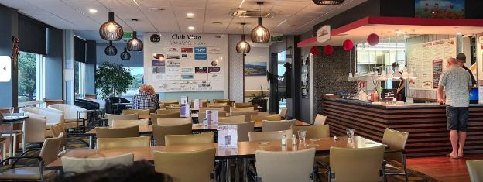*MAY LUNCHEON*

*SUNSET GRILL – CLUB VISTA*

32 Marine Parade, Paraparaumu Beach

TUESDAY 20th MAY at 12 noon

There are vegetarian and gluten free meals available

Lift available to the 1st floor

Pay on the day at the Dineout

*Charlie Metcalfe is the contact for this dineout. Phone 021 165 5362*

**😀 😀 😀 😀**

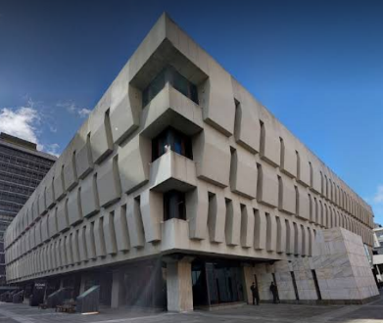*JUNE OUTING*

*NATIONAL LIBRARY AND OLD ST PAULS CATHEDRAL*

THURSDAY 5TH JUNE

Alternative Date 19th June

Leave Waikanae on **9am** Train - Walk from Railway Station to the Library – Brief intro to the facilities by staff member - Historic Landscape Photo Expo and other Expos - Reading room.

*Lunch at Home Café (to be booked).*

Historic Old St Pauls is one of the finest native timber Churches in the world – Lunchtime concert - Talk about Church and history of area.

Return home by train before 3pm.

Costs: Train Gold Card. Lunch own cost. St Pauls $5 Koha to be collected on the day.

*Contact is Maggie Copland 027 479 1487*

ONLINE PAYMENTS FOR ACTIVITIES/SUBS

Pay Online to ANZ Bank No **06-0592-0051708-00** Waikanae Millennium Rebus Club.

Please ensure you enter your name and Sub or the Activity in message or reference fields.

*GOLDEN OLDIES MOVIEMAKERS*

It is with regret we announce the disbanding of Golden Oldies Moviemakers. We commenced making movies in 2016 and since then we made 18 movies ranging from 5 to 40 minutes in length. Over 50 Club members took part with some taking leading roles and many in minor parts. Folk discovered talents they did not know they had. All enjoyed the experience and found it a lot of fun.

Alan Farquhar was the instigator in launching the group. His enthusiasm and technical knowledge helped us to produce quality movies. Rob Graham and David Goggin were his able assistants. Alison Viskovic wrote many scripts and helped organise shooting times and people. Dave Thomson as crew spent many hours patiently waiting to move lights and props.

Many thanks to all the actors and moviemakers for your participation and to our audiences for your encouragement and appreciation.

***Farewell to the Ducks***

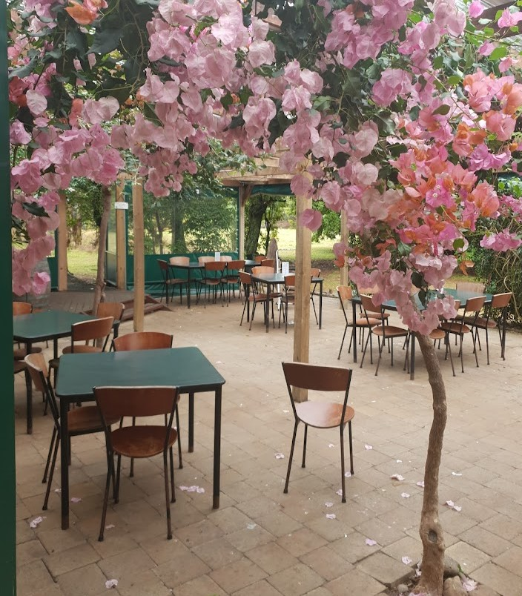A LOVELY EVENING IN

TE HORO AT

THE WINEMAKER’S DAUGHTER CAFÉ - 13 MARCH

The Millennium Group thoroughly enjoyed the evening with interesting stories and good companionship. The outstanding feature was the amount of food the café provided. It consisted of roast meats, roast vegetable, pasta, steamed vegetables, salads and a variety of sweets to round of the meal. We were lucky, as this was the last evening the café was operating. It has been sold and will be developed into a conference centre. The gorgeous pink bougainvillea and the rustic setting was very memorable. The Winemaker’s Daughter has been the scene of many enjoyable evening’s entertainment. *– Liz Thevenard*

LIFE IN THE GARAGE.

The mechanic shouted across the garage. “Hey Doc, can I ask you a question?” The famous surgeon, a bit surprised, walked over to the mechanic working on the motorcycle. The mechanic straightened up, wiping his hands and asked “Doc, look at this engine. I can open it up, take valves out, fix’em, put a new parts and when I finish this will work just like a new one. So how come I get a pittance and you get the really big money when you and I are doing basically the same work?” The surgeon paused, smiled and leaned over and whispered to the mechanic, “Try doing it while it's running.”

*KIMBOLTON RURAL SCULPTURE AND ARTS FESTIVAL*

Bus Trip to Kimbolton in the Manawatu - Saturday 5th April

Fourteen Waikanae Millennium Rebus Club members ventured into the hills of Kimbolton to the Sculptural and Arts Festival. We took two Minibuses and Dave Funnell and I drove them. There were over 5000 visitors and the day was a real community effort and is now run biannually.

We were entertained by Jazz and Brass Bands, watched 100’s of children hay jumping (which my brother set up), paint ball shooting, wool scavenger hunts, horse rides, trailer rides and lots of other entertainment. The food stalls were a real hit and with a focus on local produced products. The stars of the day were the sculptures all made from old bits and pieces such as horseshoes, bearings, spanners, engine covers, bike chains, chain saw blades, corrugated iron and old wheels. The innovation and ideas were out of this world.

Our trip home was celebrated with an ice cream and some strawberries at Lewis’s Berry Farm.

This was a very interesting and exciting day in the country. *– Liz Thevenard*

[**www.waikanaemillenniumrebus.nz**](http://www.waikanaemillenniumrebus.nz)

Above is the link for our website. We encourage you to click on the link and have a browse at the very professional production produced by our web sub-committee. We suggest you get familiar with its layout, content, looks and feel. You might well have some comments and perhaps ideas for additional content. We will always welcome your views. The site will be updated continually and we suggest you visit on a regular basis.

A very important purpose of the website is to attract new members and if talking to any interested folk please advise them to look at the website.

*A Genie granted me one wish, so I said, I just want to be happy. So now I'm living in a cottage with 6 dwarves and working in a mine.*

*# # #*

*I went to an Alcoholics Anonymous Meeting.*

*Anonymous ha! I knew everyone there!!*