NATIONAL LIBRARY AND OLD ST PAULS VISIT

The outing started with 24 people who enjoyed the Library, Lunch, and then those with the most interest and stamina the musical “Punch over Lunch” and talk at the Church. Much chatter and laughter in the train on the way home too. Most enjoyable.

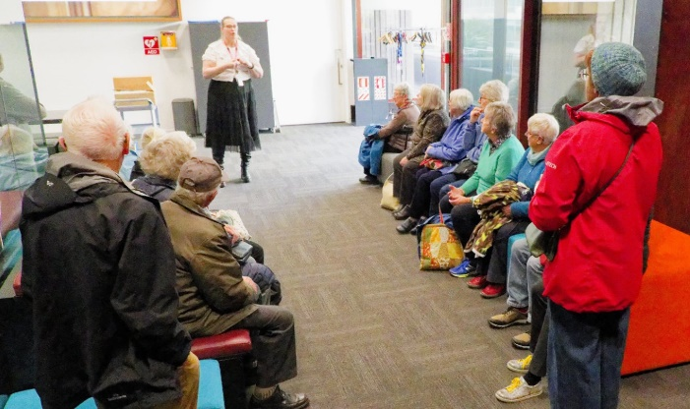
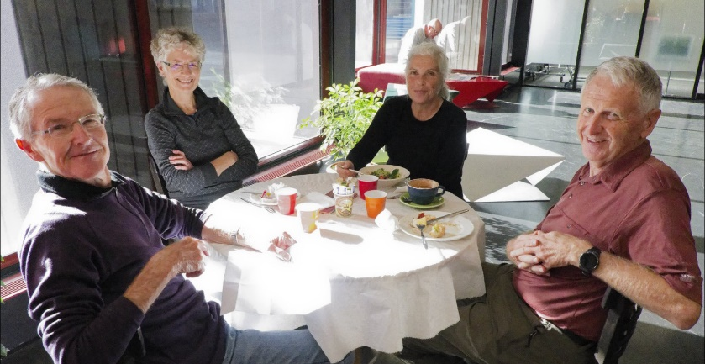
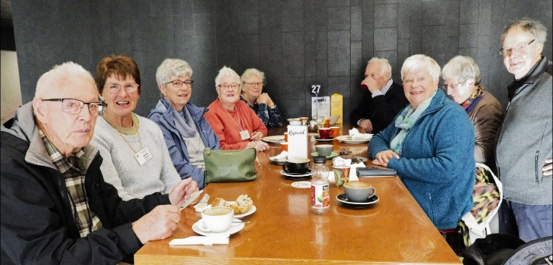
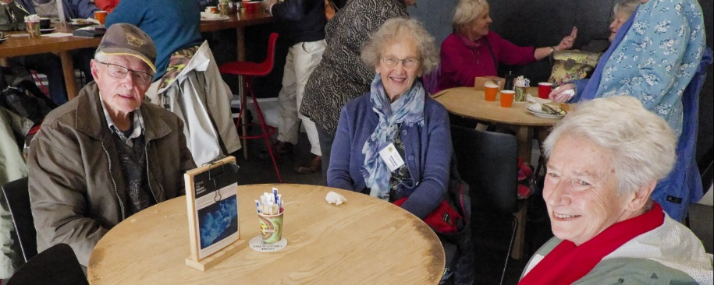
Top left a staff member gave an intro to the Librarys facilities and then we lunched at the Library Cafe

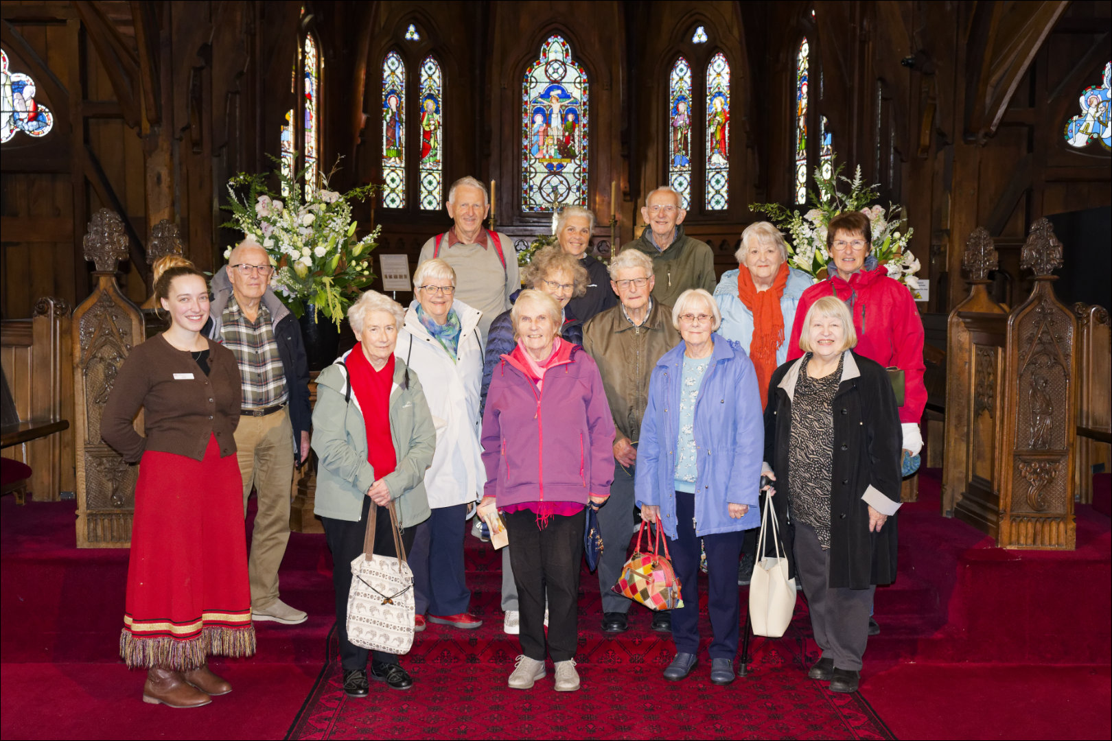

The happy travellers with their Host at Old St Pauls Cathedral

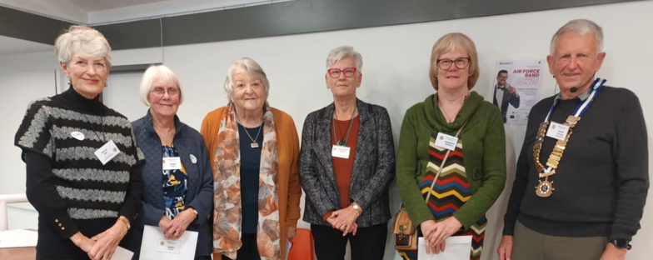
3 NEW MEMBERS WELCOMED

At our June Meeting 3 new members were inducted. From left: Joy McLeod and Jenny Chate nominated by Judy Binning. Cathy Mitchell introduced Bronwyn McDonald.
President David Funnell did the honours.

😀 😀 😀 😀

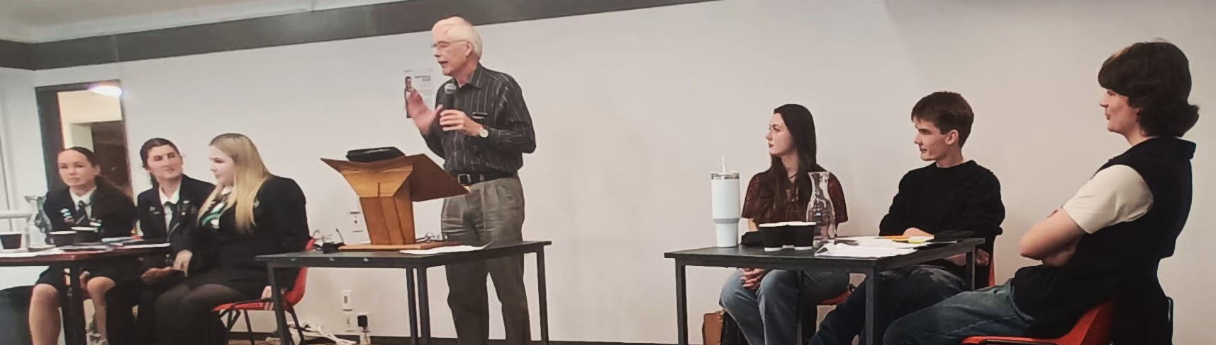
At left the Paraparaumu team. Centre the Adjudicator Bill Robertson and right the Kapiti team.

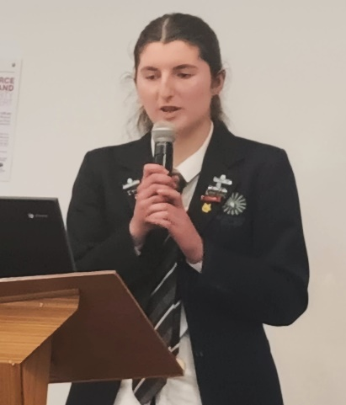

THE GREAT COLLEGE DEBATE
KAPITI versus PARAPARAUMU

THE SUBJECT: THERE SHOULD BE ONE UNIVERSAL LANGUAGE

Members witnessed a very lively debate between the two teams. All the speakers spoke clearly. strongly and very forthright with their for and against arguments.
The winner of the Evan Thomas Trophy was Paraparaumu by two points.

