

MILLENNIUM NEWS

Waikanae Millennium Rebus Club

Website: www.waikanaemillenniumrebus.nz

Vol. 26 Issue 10 OCTOBER 2025
2024

YOUR CLUB COMMITTEE 2024-2025
President David Funnell 021 260 6811 Speakers Don Mathieson 04 904 1260
Vice President Ann Harkness 027 430 3534 Almoner/Carer Judith Binning 021 168 1574
Secretary Ann Harkness 027 430 3534 Hall Set-up Liz Thevenard 021 0528 205 Treasurer Robert Johnson 027 631 3339 Newsletter David Goggin 022 6202 236
Past President Liz Thevenard 021 0528 205 Newsletter Delivery Margaret George 04 293 1313
Cameo Speakers Judith Binning 021 168 1574 Health & Safety Bruce Scott 027 442 6118
Membership/Webmaster Cathy Mitchell 04 479 2993 Archivist John Roberts 04 904 0959
Dineouts Charlie Metcalfe 021 165 5362 Speakers Shirley Clarke 027 742 3131
Outings Maggie Copland 027 479 1487
Life Members: Rob Graham, Chris Lehen, David Goggin, Hugh Scott, Alison Viskovic.

PRESIDENT’S PAGE

Even though Stefanka and I had a wonderful trip, experiencing many different cultures in various countries, it is always nice to return home and resume life with friends. One of the strengths of our Club is that other members are always willing to offer help when the need arises, and this has been evident in the past few months, with Ann taking control of the Monthly Club and Committee meetings, while Liz slotting into the Treasurers role while Robert was away and helped with the Committee meetings also. Walter kindly took over the organising of the Biking Group, so thank you all.

Last month there was a successful evening trip to Ashton Norwood Gardens, where the combinations of the blossom and lighting made for a beautiful visit. Many thanks go to our Maggie for a well organised and enjoyable trip. The next outing was to Nga Manu on the 16th October.
Charlies’ ability to arranged great dine-outs was again evident, this time at The Jolly Pub & Kitchen which was well attended and a fun social time. It makes so much difference to the Club when we have such enthusiastic organisers for any Club events. It takes a great deal of time to organise these functions, so we do appreciate all their efforts.


The October meeting was very interesting, with Shirley kindly filling in as the ten-minute speaker. Her talk should encourage the newer members to get involved in the various Clubs positions, where you can get to know more members and the rewards of being part of a great team. In the next few months, Ann will be approaching members asking them to participate in next year’s Committee, so have a positive attitude and contribute to the Club.

Our main speaker was Emma Fromings, with a very interesting address for our age group, about keeping our brain healthy. I think that by the number of questions, we all learnt something that would benefit us.

Maureen announced that she was leaving Waikanae to be nearer her family, so we all wish her the best as she relocates to Waipu.

Do not forget to book and pay for our Christmas dinner on 2nd December and the Operatunity show, which is earlier on the same day. On 18th February we will have the popular BBQ picnic, so enter that in your diaries now.

David

TIDY-UPPERS – NOVEMBER– Margaret George and Sue Hodgson

This is NOT an onerous task – vacuuming the floor only. No moving chairs or tables – just vacuuming.

PLEASE NOTE - If you are unable to do your turn, please find a replacement to stand in for you and
advise David Goggin, Phone 022 6202 236 or the President of your replacement.

Next Meeting

TUESDAY 4th November at 2pm

Waikanae Community Centre, Utauta Street

Guest Speaker: Reece Mills from Nga Manu
He will talk about the founding of our very special nature reserve, and its programmes and vision of the future. If you have never visited Nga Manu it would perhaps be a great idea to do so before the meeting.

Cameo Speaker: Liz Thevenard

WAIKANAE MILLENNIUM REBUS CLUB INC.
Notice is given that a Special General Meeting will be held on Tuesday 4th November 2025, starting at 2pm
AGENDA
Approval of Club Fees for 2026
The financial year starts on 1 January 2026.
The Club Treasurer will present a budget to support the fees to be recommended by the Committee.
Regular monthly meeting activities and speaker will follow.

APOLOGIES

Please Telephone Cathy Mitchell 04 479 2993 or 027 206 7831

PLEASE REMEMBER

# To wear your Name Tag # Tick your name on the Attendance Sheet

# Collect your Lucky Number # Support the Raffle

OCTOBER MEETING

Attendance: Present: 61 Apologies: 20 Silent: 26 Visitors: 3
Lucky Number: Earle Ritchfield Raffle: Glenys Morgan

OUR ALMONER/CARER

Our Club’s Almoner/Carer is Judith Binning. Phone 021 168 1574, email judywilliams6@hotmail.com

If you know of a club member who is not well, has had a bereavement, or may need transport to a meeting, please let Judith know. Also contact her if you know someone has a milestone birthday or anniversary coming up. Then Judith can make contact or send an appropriate card from the club.

MEMBERSHIP MATTERS

FAREWELL
Maureen Bell-McKenna has resigned from the Club. She is moving to Waipu in the far north of the country to retirement facilities and closer to family. Maureen was a Foundation Member of the Club and was an active participant in Dineouts and Outings. She also took part in some Golden Oldies movies. Her bright and breezy outlook on life and the hugs will be missed. We wish Maureen well in her new surroundings.

If your address, email, etc has changed please inform Cathy Mitchell 04 479 2993 or 027 206 7831

www.waikanaemillenniumrebus.nz

Above is the link for our website. We encourage you to click on the link and have a browse at the very professional production produced by our web sub-committee. We suggest you get familiar with its layout, content, looks and feel. You might well have some comments and perhaps ideas for additional content. We will always welcome your views. The site will be updated continually and we suggest you visit on a regular basis.
A very important purpose of the website is to attract new members and if talking to any interested folk please advise them to look at the website.
INTEREST GROUPS

WALKING GROUP
Conveners: Rosemary Wells Ph: 293 7421 and Jennifer Komar Ph 027 726 4671
Meets 9.45am every Wednesday for coffee (wet or fine) followed at 10.30 for a one-hour or 30-minute walk.
If you require transport, contact either Rosemary or Jennifer before Wednesday.

22 Oct Long Beach for Pine Ridge lookout and Waikanae Beach Walk (436)

29 Oct Olive Grove for Mazengarb Park (504)
05 Nov Harrisons for Kiripiti Reserve (201)
12 Nov Olive Grove for Pitoitoi to Killalea (423)
19 Nov Harrisons for Gear Road to Lavender Farm (208)
26 No Long Beach for Waimeha Lagoon (405)
03 Dec Long Beach for final coffee and pizza


BOOK GROUP
Convenor: Anne Wall. Phone 293 5000. Meets 2nd Monday of the month.
The Group is meeting on Monday 10th November at 2pm

at the home of Don and Sally Mathieson


CYCLING GROUP
Convenor: Walter Brock. Phone 04 904 0747
Meets every Monday morning at 9am.
If you are interested in joining this group ring Walter.


COMPUTER SUPPORT GROUP
Convenor: David Goggin, Telephone 022 620 2236
Meets 2nd Thursday of the month.
The next meeting is on Thursday 13th November at 10am
at the home of David Goggin


WRITING FOR FUN GROUP
Convenor Alison Viskovic. Phone 021 159 4945. Meets on 2nd Tuesday of the month.
Next meeting Tuesday 9th November at 2pm will be at
the home of John Barnett
We have a vacancy for one person if a newer member would like to join.


MUSIC GROUP
Convenor Diane Aviss. Phone 293 7434. Meets 3rd Wednesday of the month.
Next Meeting Wednesday 19^{h} November at 2pm
at the home of Diane Aviss



DISCUSSION GROUP
Convenor Rosemary Wells. Phone 293 7421. Meets 4th Friday each month

The group will meet on Friday 24th October at 10am
at the home of Alison Viskovic2

GARDEN GROUP
Convenor Kirsty Provan, Phone 021 0264 7486, Meets 4th Thursday morning each month.
If you want to know more contact Kirsty.

BOOK AND DVD LIBRARY
At each meeting tables laden with books, jigsaws and DVD’s are available for members to borrow. There is no checkout list to sign, it’s just help yourself and no time limit for keeping the books and puzzles.
It is requested that you make your selections before the meeting starts or during afternoon tea - not after the meeting as they are then very busy packing up.
Anyone wanting a book between meetings ring: John Harkness 021 481 85 or Ann Harkness 027 430 3534

ADVANCE NOTICE
BARBECUE PICNIC - WEDNESDAY 18 FEBRUARY 2026
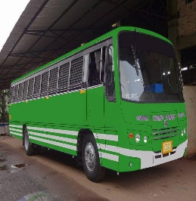
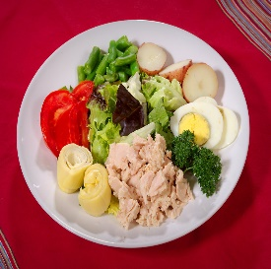
OUTINGS AND DINEOUTS
Please wear your Name Tag to all Activities

Please remember to put your name on the Intention Sheet before you pay for the Activity.

You can pay at the club meeting before
an Activity or Online.


“ITS LOOKING A LOT LIKE CHRISTMAS”

OPERATUNITY

Tuesday 2nd December
Southward Car Museum, Otaihanga

From 10am – Complimentary morning tea at venue
11am – The Concert. (Christmas song, Mime and comedy, a lot of fun)
Finish: Approx 1pm
Plenty of time to go home and get into your fineries for Christmas dinner at 6pm

Travel – Own transport. Please ask if you need a ride.
Cost - $35 per head
Payable to the treasurer by Friday the 14th of November
There are only 20 tickets reserved for this so please register early to avoid disappointment.
We will take a wait list if necessary. (members take priority)

Maggie Copland (027 479 1487) is the contact for this concert

MEET MAGGIE IN THE FOYER TO GET YOUR TICKET
GO ON TREAT YOURSELVES ITS CHRISTMAS

🎅 🤶


CHRISTMAS PARTY
and DINNER
Tuesday 2nd December at 6pm.
The Plateau Parkwood
Xmas dinner with Ham on the Bone Chicken, fresh vegetables, Christmas pudding, Apple Strudel.
A vegetarian option will be available. Tea & coffee.

Cost: Members $40.00 Guests $45.00 {includes wine and fruit juice}

Payment in advance to the Treasurer by cash or internet to obtain your ticket
Close off for payments and refunds Friday 28th November

We are pleased to welcome The Parkwood Musicians who will bring us some
Christmas music and song
Santa and Mrs Claus have been invited
!! WEAR YOUR FAVOURITE CHRISTMAS HAT !!

ONLINE PAYMENTS FOR ACTIVITIES/SUBS
Pay Online to ANZ Bank No 06-0592-0051708-00 Waikanae Millennium Rebus Club.
Please ensure you enter your name and Sub or the Activity in message or reference fields.

LUNCHEON AT “THE JOLLY” PUB & KITCHEN

Thursday 18th September
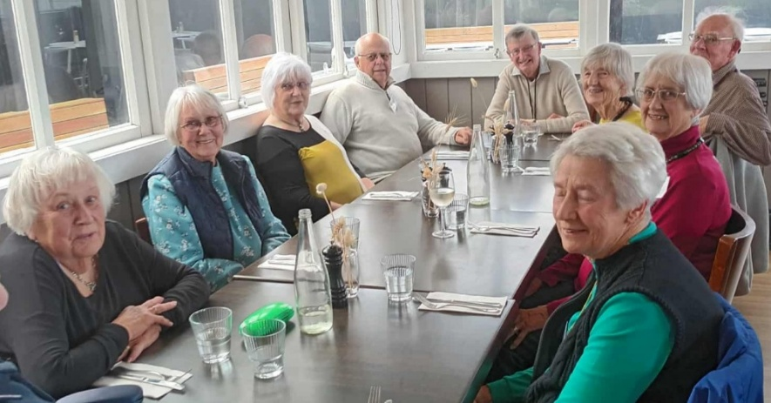
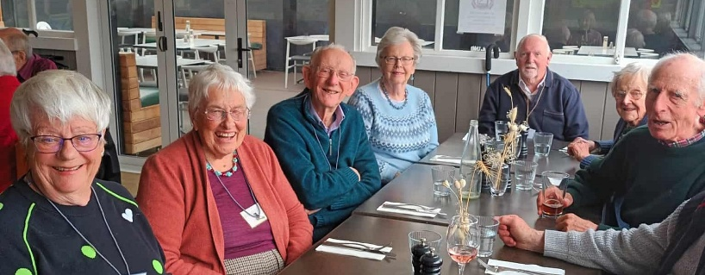
30 Club members enjoyed a wide selection of tasty meal. Lots of laughter and chat.
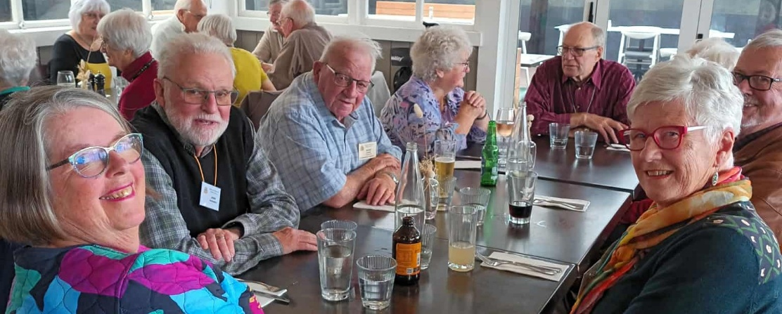
VISIT TO ASTON NORWOOD GARDEN
AFTER DARK BLOSSOM FESTIVAL
Thursday 25th September
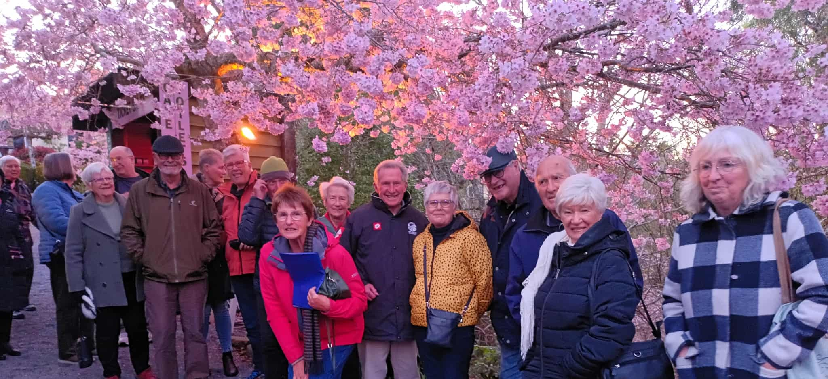
The trip to the Blossom Festival went very well we had 23 members and guests attend, an electric bus with an extremely pleasant driver, and helpful kiosk check in. Sitting under the pink frothy Sakura blossoms for dinner was like a veil over our heads. The lights added to the atmosphere with purple tree trunks, fairy lights on newly planted trees, and mirrored ponds, VERY BEAUTIFU L

