

MILLENNIUM NEWS

Waikanae Millennium Rebus Club

Website: www.waikanaemillenniumrebus.nz

Vol. 27 Issue 1 JANUARY 2026
2024

YOUR CLUB COMMITTEE 2024-2025
President David Funnell 021 260 6811 Speakers Don Mathieson 04 904 1260
Vice President Ann Harkness 027 430 3534 Almoner/Carer Judith Binning 021 168 1574
Secretary Ann Harkness 027 430 3534 Hall Set-up Liz Thevenard 021 0528 205 Treasurer Robert Johnson 027 631 3339 Newsletter David Goggin 022 6202 236
Past President Liz Thevenard 021 0528 205 Newsletter Delivery Margaret George 04 293 1313
Cameo Speakers Judith Binning 021 168 1574 Health & Safety Bruce Scott 027 442 6118
Membership/Webmaster Cathy Mitchell 04 479 2993 Archivist John Roberts 04 904 0959
Dineouts Charlie Metcalfe 021 165 5362 Speakers Shirley Clarke 027 742 3131
Outings Maggie Copland 027 479 1487
Life Members: Chris Lehen, David Goggin, Hugh Scott, Alison Viskovic.

PRESIDENT’S PAGE


A very Happy New Year to everyone, and may you all have a happy and healthy 2026. Can you believe it is 25 years since the change of the millennium and the worries that computers worldwide would cease to operate, so causing massive problems! However, the world has continued, with many more problems these days, but here in Waikanae we still enjoy the pleasant life that the Kapiti Coast offers. I hope you all had a lovely Christmas, even if the weather was not what we all had hoped for, but summer is due very soon!
At the end of last year, members enjoyed yet another performance of Operatunity at Southwards and later, the same day, we had our Christmas Dinner at Parkwood Plateau Centre, which was a great way to end the year, with good food, music, and a social time with friends. Many thanks to all of the organisers and helpers of those functions, especially Charlie for his tireless efforts.
The first event of the new year will be the BBQ – picnic on Wednesday 18th February at mid-day in the Waikanae Estuary Reserve, which is at the south end of Tutere St, with catering by two world class chefs from Ferndale. I am assured that Maggie has organised the weather for the day, to be calm, sunny but not too hot. If the Weather Gods do not oblige, then the following Wednesday will be the perfect day. Our Treasurer, Robert, is eagerly waiting for you to pay the $15 each, ASAP online or at the February club meeting for this event. Mark your calendars and commit early, so the chefs can your meal cooked on time.
Our speakers at the February meeting are going to be very interesting, so don’t miss these talks.
The Club subscriptions for 2026, of $35, are also now due, so again Robert would be pleased to have these paid sooner rather than later.
In the past month we have sadly lost two of our long serving members, Rob Graham and Maureen Rooney. Many of you will have great memories of them and of their contribution to the Club. Our thoughts are with their families at this time.
The AGM will be held at the March meeting, and Ann is at present forming the Committee for the 2026 year. Please give serious thought to how you can give back to the Club, by offering your services. At this time, the main positions to be filled are Vice President, Secretary and coordinator for the club meeting afternoon tea. Contact Ann, as she would love to hear from you, so come and join a great team.
David

SUBSCRIPTIONS ARE NOW DUE

The Subscription for 2026 is $35
You can pay at the meeting or pay online to ANZ bank number 06 0592 0051708.00, Waikanae
Millennium Rebus Club. Please ensure you enter your name, and 2026 sub in message or reference fields.

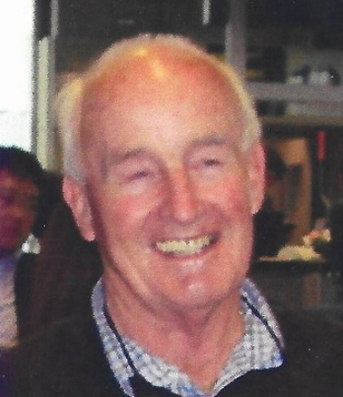
ROB GRAHAM
With deep regret we record the passing of Rob Graham. Rob was a Foundation Member and a Life Member of the Club. In the last few years he has been in care. Rob was President in 2002-3 and was involved in organising dineouts and outings. He was a member of the Computer, Golf and Walking groups. Rob was one of the founding members of the Golden Oldies Moviemakers group, He was very involved in many of the Club activities He was Editor of the Newsletter for a long period. Our sympathy has been extended to the family.

MAUREEN ROONEY
Sadly we record the death of Maureen. She had been a member since 2005 and was a regular attendee at meetings. Maureen acted in some of the movies made by the Golden Oldies. A memorable part was crashing a car into a tree and then shooting dead the guy chasing her.
Our Carer has made contact with the family conveying our sympathy.

Next Meeting

TUESDAY 3rd FEBRUARY at 2pm

Waikanae Community Centre, Utauta Street

Guest Speaker: Hilary Cunningham-Orr
“Women in Aviation”
Hilary Cunningham-Orr will take us through an informal journey exploring the successes and failures of some of our best known and some not so well known Queens of the Air from record-breakers to test pilots. From single seat to military bombers. From the wealthy aristocracy to the New World check-out girl - they have all been seduced by the power of flight. “Once you have tasted flight, you will forever walk the earth with your eyes turned skyward, for there you have been and there you will always long to return.”

Cameo Speaker: Diana Roberts
“My Life With Food”

APOLOGIES

Please Telephone Cathy Mitchell 04 479 2993 or 027 206 7831

PLEASE REMEMBER

# To wear your Name Tag # Tick your name on the Attendance Sheet

# Collect your Lucky Number # Support the Raffle

TIDY-UPPERS – FEBRUARY – ROSEMARY and NEVILLE HURD

This is NOT an onerous task – vacuuming the floor only. No moving chairs or tables – just vacuuming.

PLEASE NOTE - If you are unable to do your turn, please find a replacement to stand in for you and
advise David Goggin, Phone 022 6202 236 or the President of your replacement.

OUR ALMONER/CARER

Our Club’s Almoner/Carer is Judith Binning. Phone 021 168 1574, email judywilliams6@hotmail.com

If you know of a club member who is not well, has had a bereavement, or may need transport to a meeting, please let Judith know. Also contact her if you know someone has a milestone birthday or anniversary coming up. Then Judith can make contact or send an appropriate card from the club.

INTEREST GROUPS

WALKING GROUP
Conveners: Rosemary Wells Ph: 293 7421 and Jennifer Komar Ph 027 726 4671

Meets 9.45am every Wednesday for coffee (wet or fine) followed at 10.30 for a one-hour or 30-minute walk.
If you require transport, contact either Rosemary or Jennifer before Wednesday.

04 Feb Harrisons Café for Peka Peka Road to Gary Road (305)
11 Feb Kowhai Eatery Otaki Main Road for Railway Station to Racecourse (107)
18 Feb Long Beach for Tutere Street and Beach Walk and Barbecue (401)
25 Feb Long Beach for Peka Peka Beach Walk (304)
04 March 180 Degrees for Green Spaces of Kena Kena (518)
11 March Harrisons for Beach Settlement (205)

INFORMAL AND UNORGANISED WEDNESDAY WALKS
21st -28th January
While the Walking Group is having its yearly break, folk are welcome to join in this unorganized socialising time. Meet at The Olive Grove Café at 9.45pm for coffee and a chat and then go for a leisurely local stroll (optional). No shifting of cars and no idea where we go till the day.
You can just come for coffee - you don’t have to walk.
The formal and organised Walking Group will recommence on 4th February


BOOK GROUP
Convenor: Anne Wall. Phone 293 5000. Meets 2nd Monday of the month.
The Group is meeting on Monday 9th February at 2pm

at the home of Anne Wall


CYCLING GROUP
Convenor: Walter Brock. Phone 04 904 0747
Meets every Monday morning at 9am.
If you are interested in joining this group ring Walter.


COMPUTER SUPPORT GROUP
Convenor: David Goggin, Telephone 022 620 2236
Meets 2nd Thursday of the month.
The next meeting is on Thursday 12th February at 10am
at the home of David Goggin

.


WRITING FOR FUN GROUP
Convenor Alison Viskovic. Phone 021 159 4945. Meets on 2nd Tuesday of the month.
Next meeting Tuesday 10th February at 2pm will be at
the home of Alison Viskovic
We have room for one more member - if you are interested phone Alison, 021 159 4945, to learn what we do.


MUSIC GROUP
Convenor Diane Aviss. Phone 293 7434. Meets 3rd Wednesday of the month.
Next Meeting Wednesday 18th February at 2pm
at the home of Gaynor Bass



DISCUSSION GROUP
Convenor Rosemary Wells. Phone 293 7421. Meets 4th Friday each month

The group will meet on Friday 23rd January at 10am
at the home of Rosemary Wells

GARDEN GROUP
Convenor Kirsty Provan, Phone 021 0264 7486, Meets 4th Thursday morning each month.
If you want to know more contact Kirsty.



OUTINGS AND DINEOUTS
Please wear your Name Tag to all Activities

Please remember to put your name on the Intention Sheet before you pay for the Activity.

You can pay at the club meeting before
an Activity or Online.

BAR - BE - CUE PICNIC

WEDNESDAY 18th FEBRUARY
12 noon
WAIKANAE ESTUARY
End of Tutere Street Entrance
First Picnic Area on the Left

Hamburgers, Sausages and Bread
Bring own Drinks, Plates, Cutlery,
Chairs, Hats, Sunblock.
There will be some shade provided.

Cost $15 –Pay at Club Meeting or Online
Please enter your names on the intention sheet at the next meeting for catering purposes.

FINGERS CROSSED THE DAY WILL BE FINE
Contact is Maggie Copland 027 479 1487

🥖🫓🥖🫓🥖 🍕🍕🍕

MARCH LUNCHEON
MEDITERRANEAN FOODS TRATTORIA AND DELI
Coastlands Parade, Coastlands.
They will present a Classic Neapolitan Pizza Menu
for us on
THURSDAY 19th MARCH – 12pm
There is excellent parking and access to the venue
Pay individually on the day
There will be a notice at our February meeting for you to enter your name for this Dineout
Any enquires Charlie Metcalfe. 0211655362

ONLINE PAYMENTS FOR ACTIVITIES/SUBS
Pay Online to ANZ Bank No 06-0592-0051708-00 Waikanae Millennium Rebus Club.
Please ensure you enter your name and Sub or the Activity in message or reference fields.

BOOK AND DVD LIBRARY
At each meeting tables laden with books, jigsaws and DVD’s are available for members to borrow. There is no checkout list to sign, it’s just help yourself and no time limit for keeping the books and puzzles.
It is requested that you make your selections before the meeting starts or during afternoon tea - not after the meeting as they are then very busy packing up.
Anyone wanting a book between meetings ring: John Harkness 021 481 85 or Ann Harkness 027 430 3534

SHINGLES PREVENTION STUDY

Shingles (Herpes Zoster) is a painful skin rash, caused by the same virus that causes chickenpox. After a person recovers from chickenpox, the virus can lie dormant and reactivate later in life. Adults 70 years of age and older are at higher risk for shingles and its complications. Although there is an approved vaccine, researchers are working to develop potential new options that may improve protection and reduce side effects.
We are inviting adults to join a clinical research study evaluating a new investigational vaccine for shingles (herpes zoster). The study is evaluating the tolerability and safety of the investigational vaccine and whether it can trigger an immune response. Researchers are comparing the investigational vaccine with Shingrix (an existing and approved shingles vaccine). Participants will receive two vaccine doses and return for follow-up visits over the next year. All study-related care and medicines are free, and participants may be compensated up to $900 for this study.
You may be able to join if you:
• Are 70 years or older
• Have not previously received a shingles or chickenpox vaccine
• Have not caught shingles in the past
Other eligibility criteria apply.
If you think you might qualify, we invite you to register your interest today!
Sign up here:
https://www.momentumclinicalresearch.co.nz/clinical-trials/zoster-vaccine-studies-kapiti-zos/
or call 04 908 1001 to learn more.

www.waikanaemillenniumrebus.nz


Above is the link for our website. We encourage you to click on the link and have a browse at the very professional production produced by our web sub-committee. We suggest you get familiar with its layout, content, looks and feel. You might well have some comments and perhaps ideas for additional content. We will always welcome your views. The site will be updated continually and we suggest you visit on a regular basis.
A very important purpose of the website is to attract new members and if talking to any interested folk please advise them to look at the website.



My husband said we need to stop travelling so much and start saving some money.
So I went by myself and I saved 50%.

# # #

Why do British people never sound British when they sing?


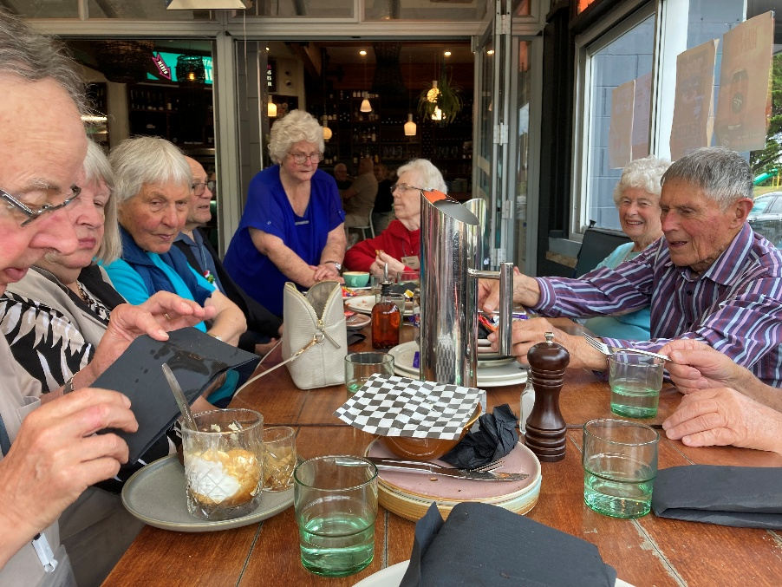
WALKERS END OF YEAR LUNCH
Folk were fascinated with John’s Affogato

